**SCREENSHOT FILE**

**Course-end Project 1**

**Set Up and Monitor a WordPress Instance**

**Step 1: Launch a WordPress instance using Cloud Formation**

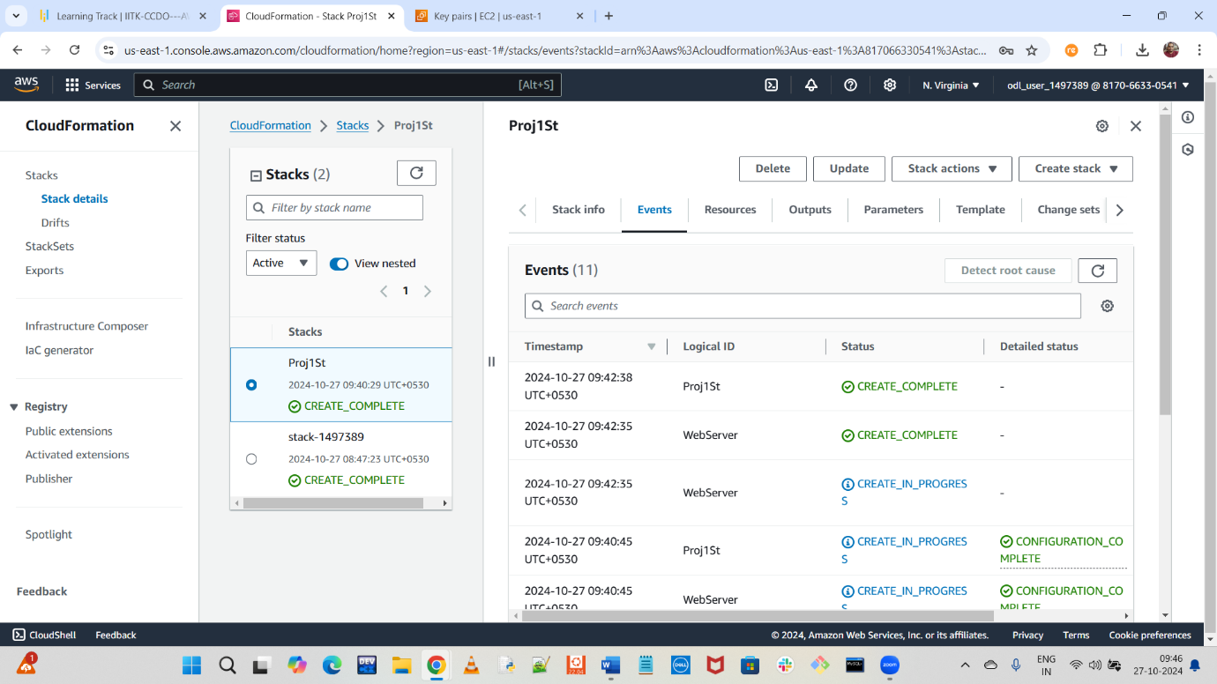

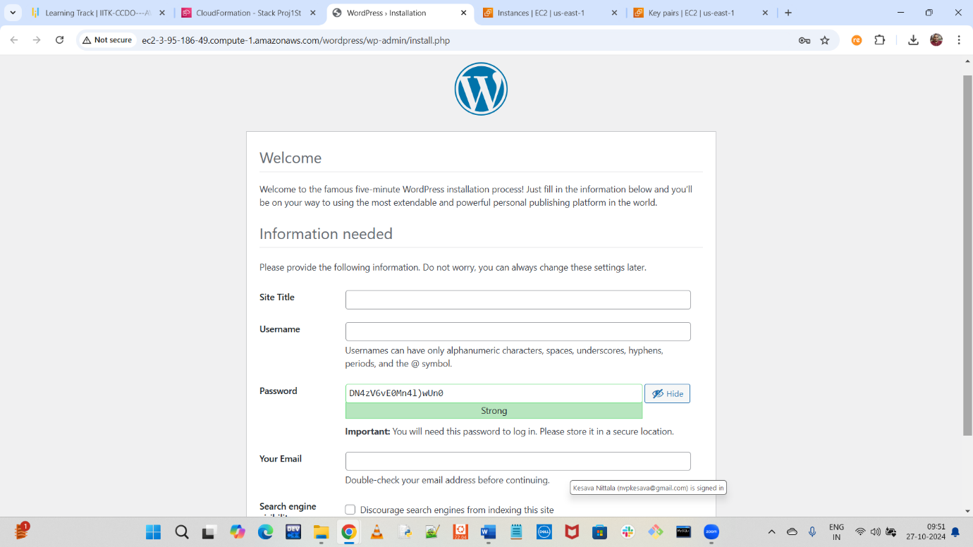

**Step 2: Create AMI from first WordPress instance**

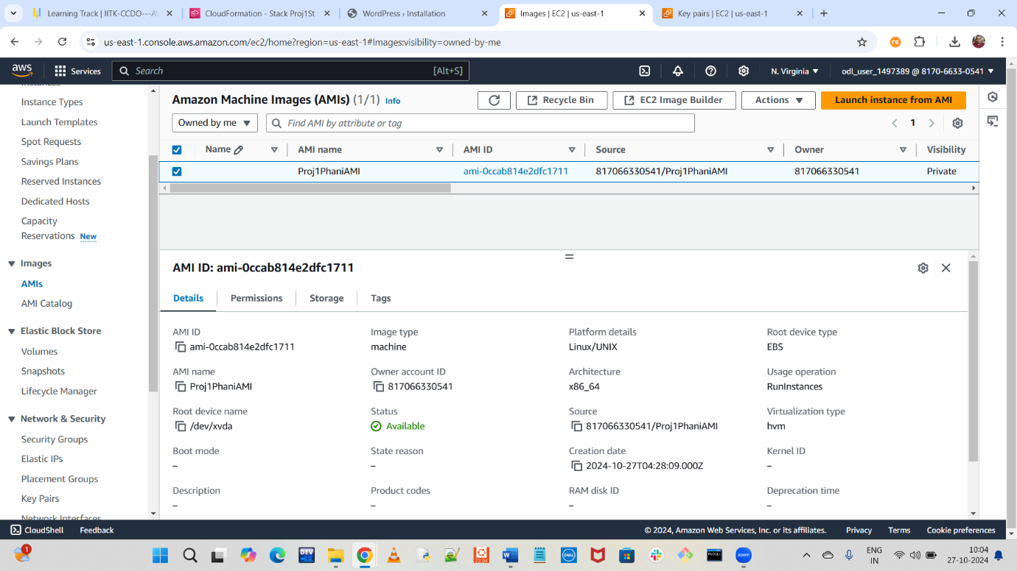

**Step 3: Launch a new WordPress instance (9AM – 6PM) using AMI of first instance**

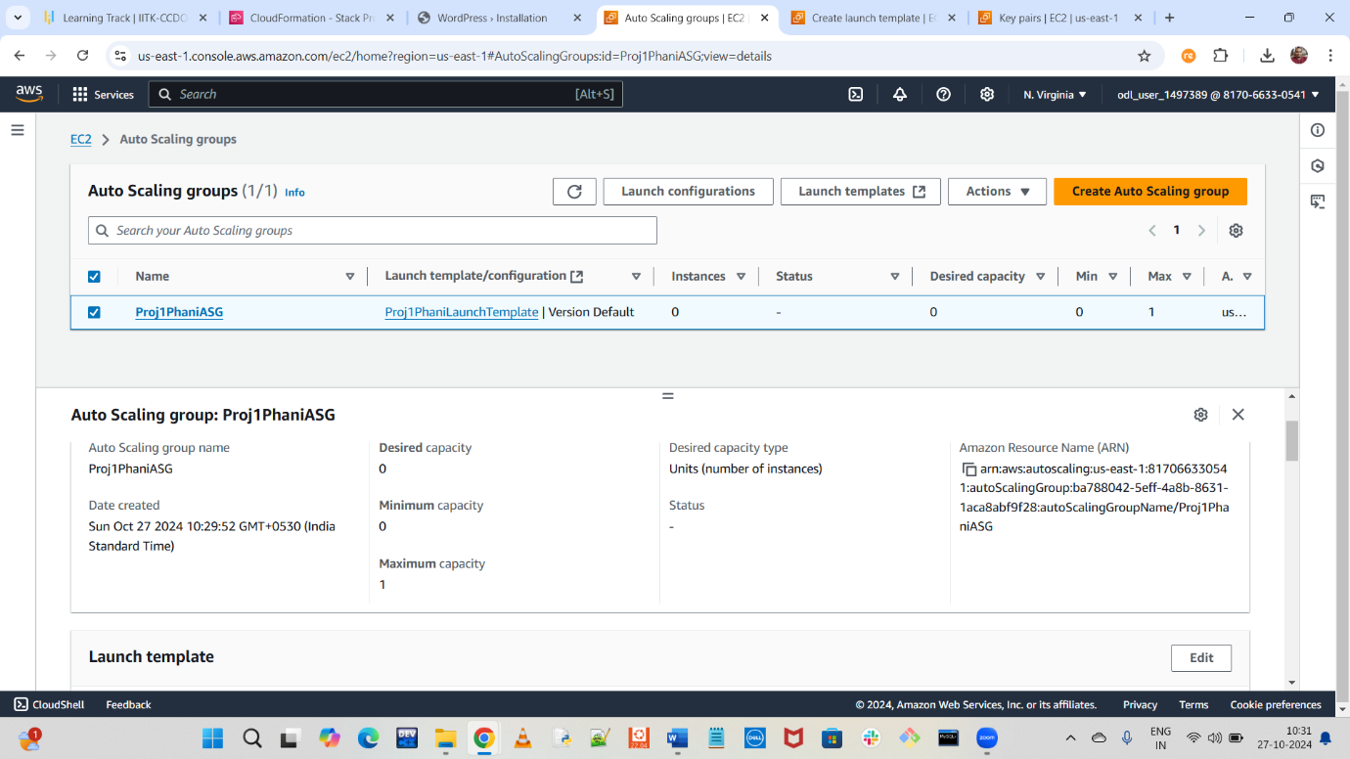

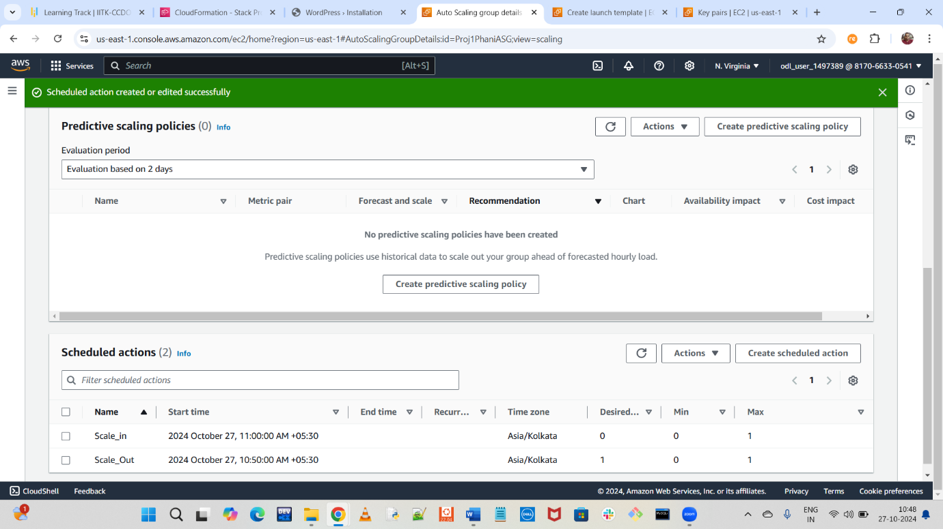

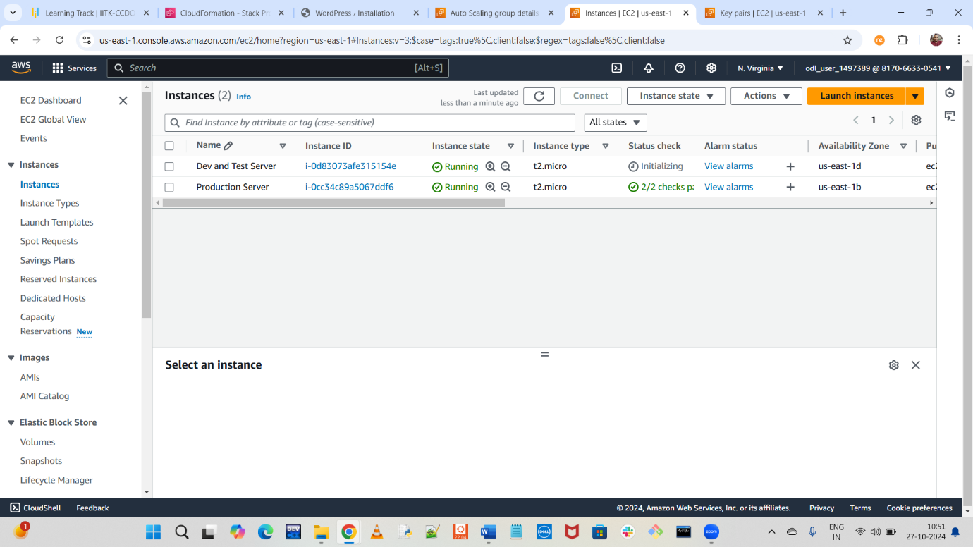

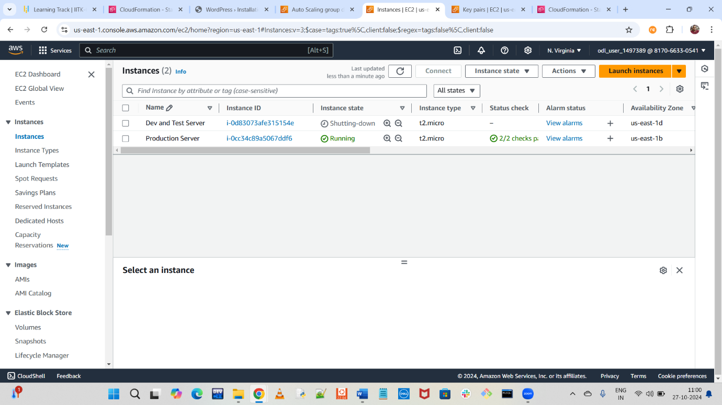

**Step 4: Check Availability Monitoring of WordPress Instance using Route53**

